04th December 2017

**Thed Bjork Is The New FIA WTCC Champion\***

The FIA World Touring Car Championship came to an end of the season finale full of drama and excitement as expected. The final rounds of the Championship with Japanese Tyre manufacturer YOKOHAMA as official Tyre supplier were held at the weekend at the Losail circuit in Qatar and saw the Swede Thed Bjork crowned as World Champion*, in his second full WTCC campaign with factory Polestar Cyan Racing team. Ably assisted by 4 times World Champion Yvan Muller, who came back from retirement only for the Qatar races to support and secure the manufacturer’s title to the Swedish Volvo Polestar, Bjork kept his calmness throughout the races with wins at Monza and Nürburgring Nordschleife, which was key to his consistency and Championship triumph. The Hungarian Norbert Michelisz had to settle for second overall, following some trouble with his brakes in qualifying and a difficult race weekend in Qatar.

Tom Chilton managed a splendid but hard fought victory in the Opening race, which placed him on track and to eventually achieve the WTCC Trophy which rewards independent drivers. Chilton, ever the gentleman was ecstatic but honourable praising and respecting the good season Team mate Bennani also had and what a joy it is to drive among the best. With his first place and a fifth in the Main race, Chilton had done enough to secure the WTCC trophy and a meritorious overall third place. In the Main race, Esteban Guerrieri marked an impressive debut WTCC bid with victory for Honda and Huff and Catsburg completing the podium.

In the Main Race, former ETCC Champion Richard made up for his hesitant start in the first counter, passing Muller with an audacious move to finish sixth on only his fourth WTCC start. Filippi and Michigami rounded out the points scorers, with Coronel just missing out in P11. Bennani retired with damage following first-corner contact with Muller.

After the race, Thed Björk stated his happiness, “It’s incredible now I’ve calmed down a bit but it was completely crazy at the finish with so many feelings. I felt really good driving here. It obviously made it easier with the problems Honda had with Norbert but I feel like I’ve been putting the championship together all year. For me I felt like I won it in Macau because it was my first time there and these guys had been there and I was just trying to keep the lead because Norbert was really fast there. But it just feels good now. It’s fantastic to be a part of the group. I have to send my thoughts to Tiago Monteiro because he had to leave the championship because of an accident. Big respect to Tiago and I am missing him a lot and I send all my best to him. I hope he can come back and take another championship because he deserves it.”

**Overall Driver Championship WTCC 2017**

1. Thed Bjork 283,5 pts
2. Norbert Michelisz 255 pts
3. Tom Chilton 248,5 pts

**Manufacturers Championship**

1. Volvo Polestar 908,5 pts
2. Honda 880 pts

**WTCC Trophy Winner (Privateers)**

Tom Chilton

*All Championship titles are subject to confirmation by the FIA.

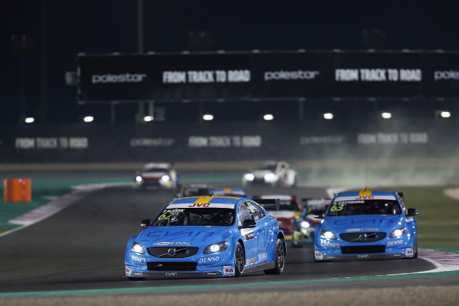

*Bjork leads on his Volvo S60 Polestar - photo Jean Michel le Meur*

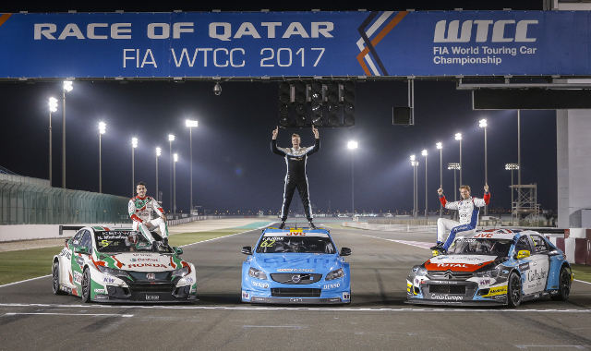

*Champion Bjork in the centre flanked by Michelisz on the left 2nd overall and Chilton on the right 3rd overall - photo Francois Flamand*

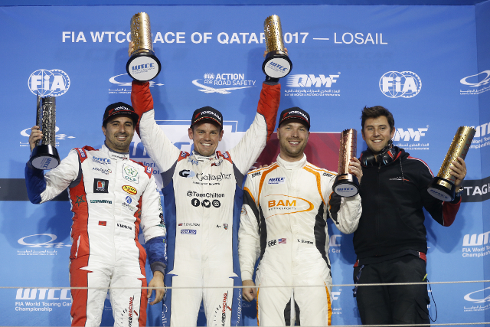

*Chilton Winner opening race with Bennani in second and Gleason in third - photo jean Michel le Meur*